**WEKA ASSIGNMENT**

**BY: HARISH P**

**1. DATASET DESCRIPTION:**

Dataset Name: Glass

Source of the dataset: https://github.com/renatopp/arff-datasets/blob/master/classification/glass.arff

Dataset description: The data set contains 1 classes of 214 instances each where each class refers to a type of glass.

No of attributes: 10

No of instances: 214

**2. INPUT & OUTPUT:**

|  |  |  |
| --- | --- | --- |
| GLASS | 1.RI  2.Na  3.Mg  4.Al  5.Si  6.K  7.Ca  8.Ba  9.Fe  10.Class | Duration: class  Na: class  Mg: class  Al: class  Si: class  K: class  Ca: class  Ba: class  Fe: class |

**3. DATA PREPARATION:**

Removal of null data types, empty instances and false attribute.

**4. SELECTING AN ALGORITHM:**

|  |  |  |
| --- | --- | --- |
| **Algorithm** | **Result from Weka** | |
| **Correctly Classified Instances** | **Mean Absolute Error** |
| **Weka Classifiers** | | |
| NaiveBayes | 104 | 0.1541 |
| NaiveBayesMultinominal | 112 | 0.167 |
| NaiveBayesMultinominalText | 76 | 0.2118 |
| **Weka Classifiers Functions** | | |
| SimpleLogistic | 137 | 0.1423 |
| MultilayerPerceptron | 145 | 0.1114 |
| **Weka Classifiers Meta** | | |
| LogitBoost | 153 | 0.1027 |
| Bagging | 155 | 0.1206 |
| **Weka Classifier Trees** | | |
| J48 | 143 | 0.1026 |
| RandomTree | 150 | 0.0854 |
| **Weka Classifier Rules** | | |
| OneR-B 6 | 124 | 0.1202 |
| JRip | 147 | 0.115 |

**5.DATA PREPROCESSING:**

|  |  |
| --- | --- |
| **Attribute Evaluator** | Classifier Subset Eval (Classifier: meta.Bagging with training parameter: classifiers = J48 and the others in their default) |
| **Search Method** | BestFirst (Direction: Forward) |
| **Evaluation Mode** | 10-fold cross-validation (Folds = 10, Seed =1) |

**6.TREE PRODUCED:**

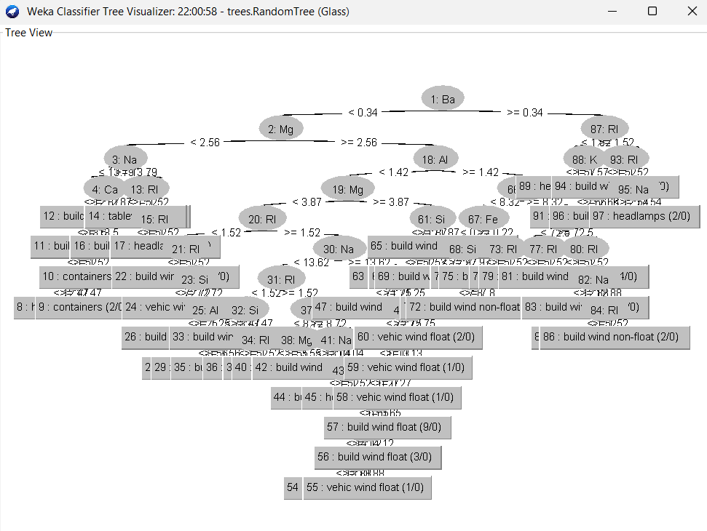

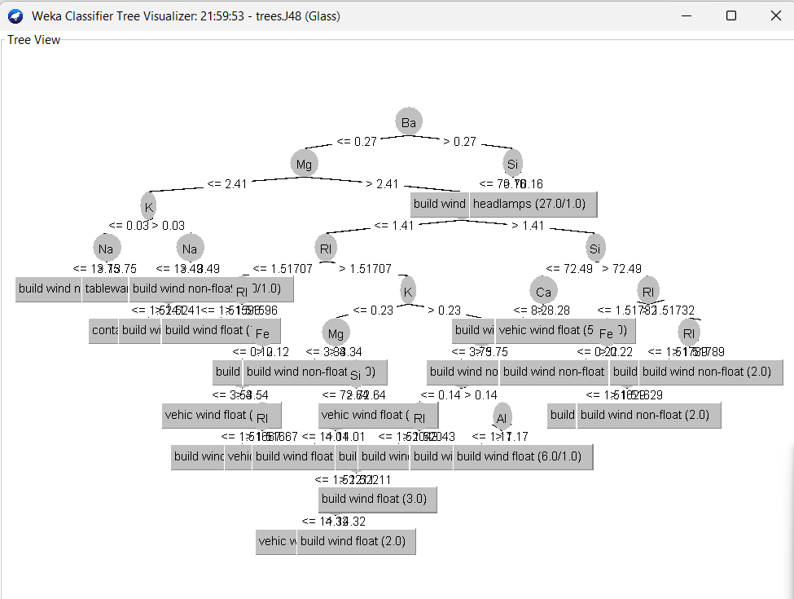

**7. SCREENSHOTS:**

